**Comet Time Series (CometTS) Expansion for Landsat Imagery**

In a recent blog post we introduced Comet Time Series (CometTS) and showed a use-case with Suomi NPP nighttime imagery to estimate changes to populations over time. As a follow-up, this blog will explore the use of CometTS and multispectral imagery, specifically a time series of Landsat data. Landsat is the worlds’ longest running multispectral imaging remote sensing platform, with a lifespan stretching from 1972-Present. Current versions of the satellite offer a 30-meter ground sample distance (GSD), a maximum revisit cycle of 16 days, a 185 km swath, and a broad spectral resolution stretching from visible blue to shortwave infrared[1]. Presently, Landsat 7 Enhanced Thematic Mapper+ (ETM+) and Landsat 8 Operational Land Imager (OLI) are in orbit, with the launch of Landsat 9 planned for December 2020. The purpose of this blog will be to explore the usage of a time series of Landsat imagery with CometTS and introduce expansion code that is purposefully built for working with Landsat data. This code should offer easier transferability to other multispectral satellites for future workflows. Through this exercise we will walk through using the USGSs’ EarthExplorer website to download a time series of Landsat imagery, the cloud masking of that imagery, and finally loading our cloud masked products into CometTS and running an initial change detection analysis.

**Working with EarthExplorer**

EarthExplorer <https://earthexplorer.usgs.gov/> is the USGS’s main portal to access, preview, and download multiple types of imagery, including Landsat. All the imagery found here is free to the public and the interface allows you to explore all corners of the earth in a Google Maps-esque style. To start, navigate to earthexplorer.usgs.gov, and select the login or registration button in the top right corner to login/create an account, which is required to download imagery. For my area of interest, I’ve elected to investigate the effects of flooding after Hurricane Katrina in communities in New Orleans, Louisiana.

EarthExplorer is broken down in a column/row based criteria (left side of the screen) and should be worked through left to right and top to bottom. Starting with the first tab, “Search Criteria” we can start our search for imagery. Landsat images are distributed in a World Reference System 2 (WRS2) path/row format. This system is a row and column format as the overpasses of the Landsat satellites are always consistent and the images share the same footprints and extent every 16 days. Using a single path/row is the best practice for time series analysis and ensures that the extent and georeferencing of your imagery remains consistent over time. There is some overlap in the path/row system; consequently if you pick a location of interest that is covered by multiple path rows, you could end up with a Landsat dataset with inconsistent extents that will require more organizational skills and preprocessing to get into a usable format.

I would recommend using this tool: <https://landsat.usgs.gov/wrs-2-pathrow-latitudelongitude-converter> to ensure you are working with the proper path/row. For me, New Orleans happens to fall perfectly in the center of path/row 22/39. Consequently, under the “Search Criteria” tab, I will enter Path/Row 22/39, retain the “Point” option and then click “Show”. This will select a point on the map that should be close to your AOI. (Figure 1)

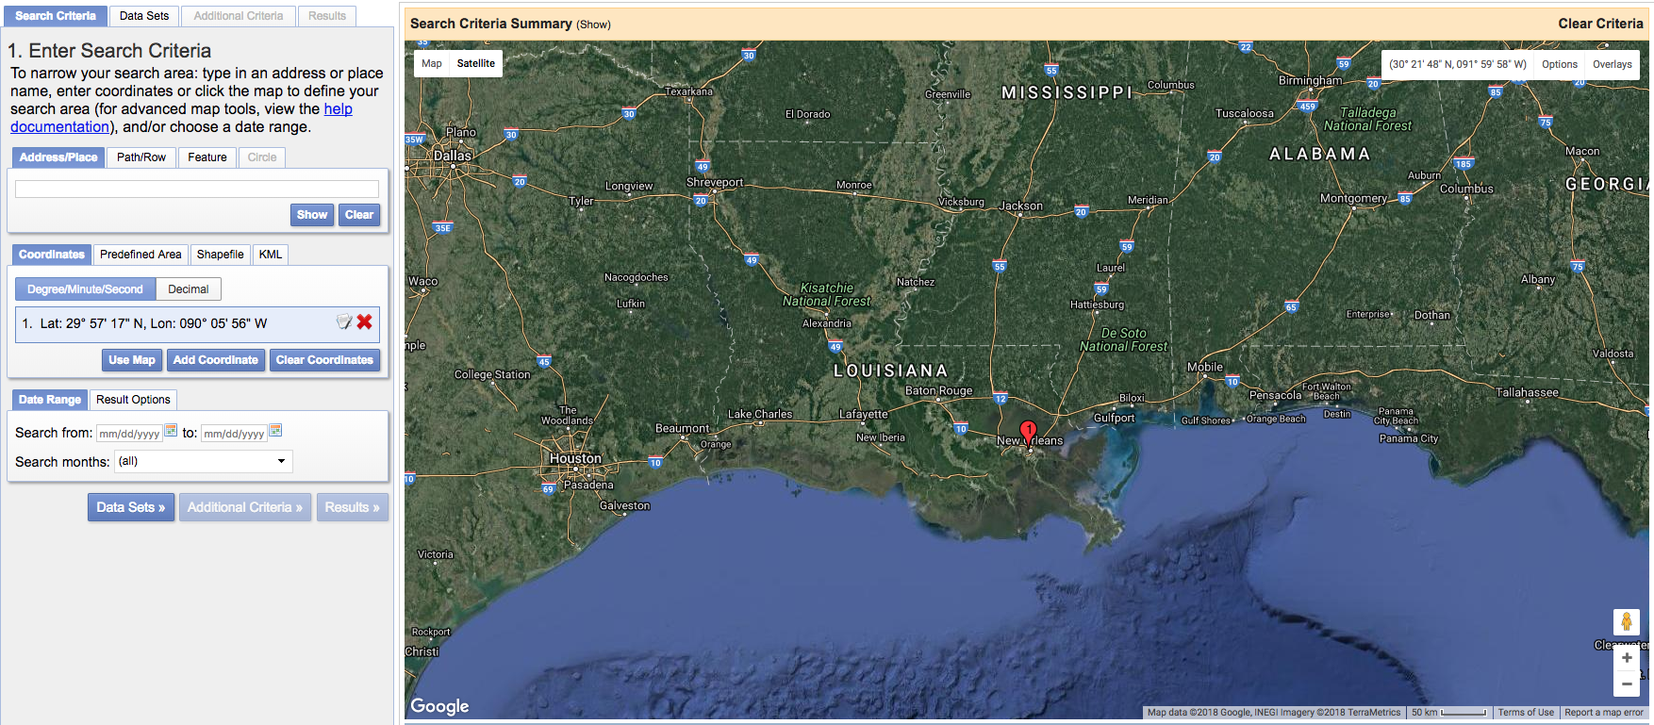

**Figure 1: Selecting our area of interest within EarthExplorer.**

Under “Date Range”, I want to explore data from January 1st, 2000 to Present. This will cover three instances of the Landsat satellite: Landsat 5, 7 and 8. Landsat mission 6 does not exist as the satellite failed to reach orbit after launch. Next to the “Date Range” tab, click on the “Result Options” tab and select the number of records to return to be greater than 500, as we do not want to limit our search results (Figure 2).

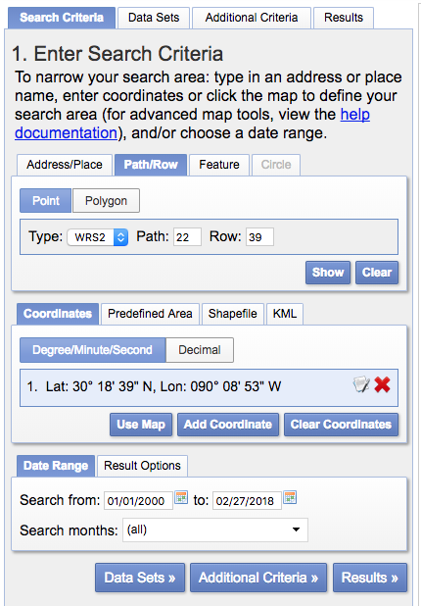

**Figure 2: An example of the search criteria interface.**

Now we are ready to move onto the “Data Sets” tab and scroll down to Landsat. Here we are going to be working with the “Landsat Collection 1 Level-2 (On-Demand)” data. (Figure 3). These data are atmospherically corrected to display surface reflectance, orthorectified, and span the entire extent of the Earth unlike the “Analysis Ready Data” which is confined to the US only. This level of preprocessing ensures that the imagery is of optimal clarity, is standardized to surface reflectance across all 3 satellites, and has minimal atmospheric effects that could cause more inter-pixel variability across each satellite image. Such variability can add noise to a time series analysis and make our results less likely to be correct. Additionally, orthorectification ensures that the effects of terrain are minimized and that the GSD is consistent across the entire image despite changes in elevation or slope of the landscape. Here we will select the 3 datasets we are interested in working with: Landsat 8, 7, and 4-5.

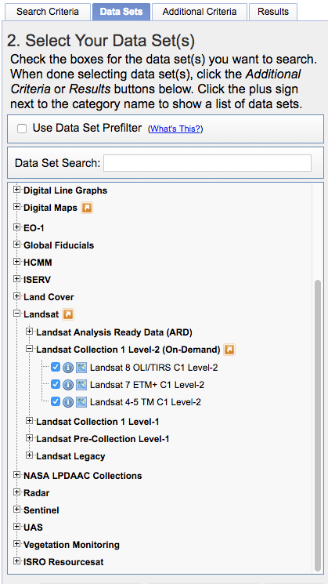

**Figure 3: The dataset of three Landsat satellites that we will be working with**

Once this is done we will move over to “Additional Criteria” tab to prune our resulting files a bit. We will have to work through each of the 3 Landsat products for this step. For ***each*** (3 times total) data product: 1)Set Land and Scene Cloud cover to “Less than 50%”, 2) the Collection Category to “Tier 1” and 3) the Data Type Level-1 to “Level 1TP”, which ensures the data are processed and orthorectified in a standardized fashion to the highest quality standards (Figure 4). Once done with this we can move to the “Results Tab”. Here we can preview a coarse resolution product, and also view the footprint of each image (Figure 5).

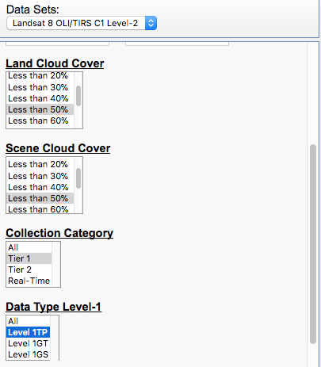

**Figure 4: Preferred settings for downloading our Landsat imagery.**

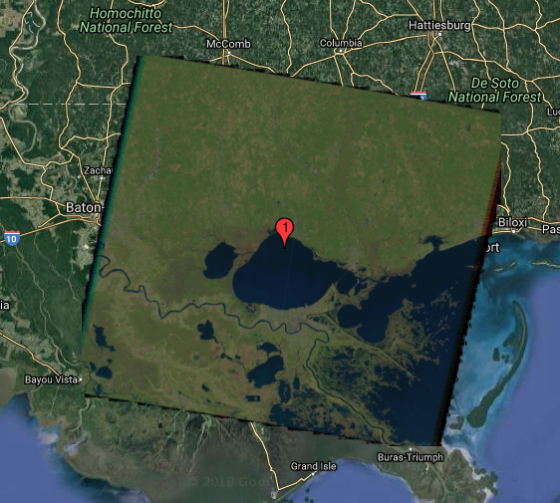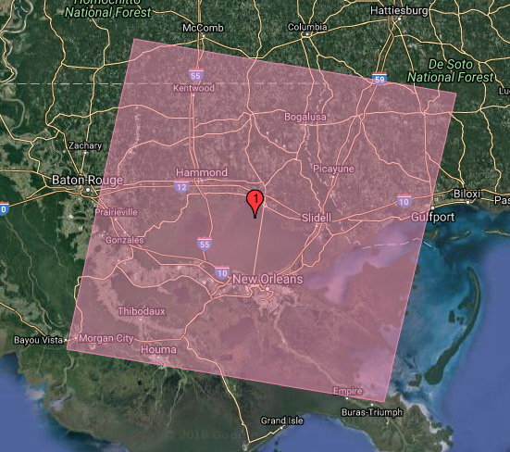

**Figure 5: An image and footprint preview of one of our scenes we will download.**

To ensure we order all the scenes we want, click this little “i” to make sure your results are not limited. Next under the “Hide Result Controls” dropdown click the link that says “Click here to export your results”. (Figure 6)

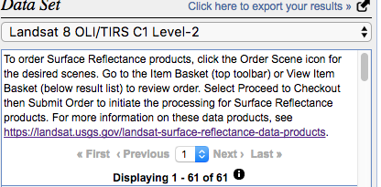

**Figure 6: The dataset interface; note the small “i" in the lower center of the interface and the button to export results on the upper right.**

We are going to create a list of unique product identifiers to create a large batch order that we can submit to the USGS for processing. For ***each*** of the 3 satellites, go through and do a metadata export. Be sure to choose “Non-Limited Results and CSV format” when using the export (Figure 7). The USGS will now email you 3 CSV files that are zipped up. We will use these to create a text list of scene names that we will submit to another website for processing.

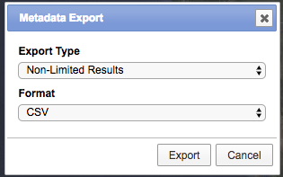

**Figure 7: An export routine to generate a CSV list of images that we will order from the USGS.**

Once you download, unzip and open each of the 3 CSV files (preferably in a spreadsheet manager program), you can then extract the “Landsat Product Identifier” from the far left column, and copy and paste it into a word document. You do not need a column header (Figure 8).

Once you have done this for all 3 files, save your text document as a .csv. I ended up with 429 Landsat images, which is a fairly standard time series to work on. If this is too much data, you may want to constrain the dates of collection to a 5 to 10 year period and revisit the EarthExplorer order of operations.

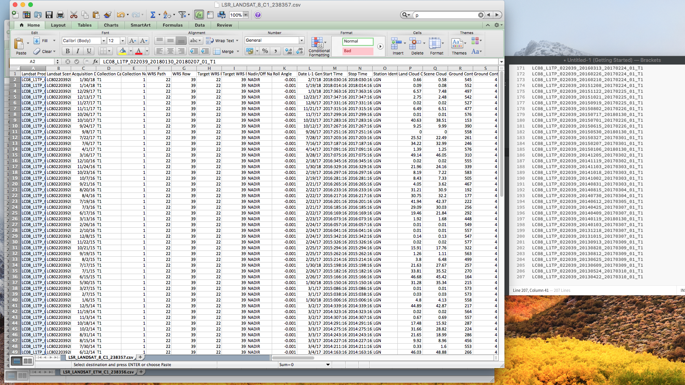

**Figure 8: Creating a list of product identifiers for ordering.**

Now navigate to: espa.cr.usgs.gov and login using the same information you used to login to EarthExplorer. Click on “Order Data” under the “Bulk Ordering” header. For the scene list choose the CSV you just created. Under “Additional Processing (Landsat Only)” Choose “Surface Reflectance” and “Pixel QA”. Surface Reflectance is our atmospherically corrected product, and Pixel QA is used for our cloud masking process. If you would like some spectral indices precalculated for you, like NDVI, click under Spectral Indices and select those you are interested in. I’d recommend outputting as a GeoTiff. Once you are finished, click “Submit”.

Sometimes you will get an error like this one:

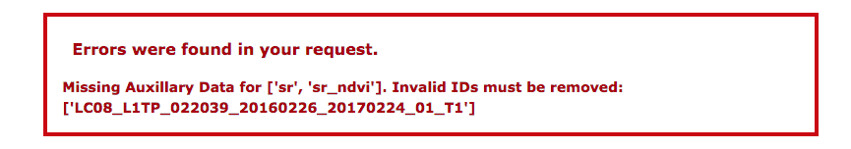

This just means that this level of processing is not available for this particular scene. Simply remove it from your order list and resubmit the order. Once you are finished and the order is successfully submitted, you will receive an email. Processing time may take several hours or even days for larger orders so be aware of this ahead of time. Once it is finished you will receive another email stating that your imagery is ready for download. Note that downloading, unzipping, and cloud masking all of your data may also take an additional day, so patience is key.

**Download and Unpack Your Data**

My processing time was relatively short at 8 hours. I then downloaded all scenes using the Chrono download manager (http://www.chronodownloader.net/) and Google Chrome. A slightly more robust option is DownThemAll (https://www.downthemall.net/) and Mozilla Firefox (not compatible with Firefox Quantum). Be sure to have enough space on your drive to download and then eventually unzip the products. When compressed my 428 images were just over 141 GB. Once unzipped, I had 320 GB of data, so you may need over half a terabyte of space to run such a large analysis. The data are distributed as tarballs and most common compression programs can handle this file format, however if you would like to use a script for automation and organizational compatibility with CometTS I have attached one (LS_Untar.bash)

This is a bash file, simply copy and paste it to the same folder as your Landsat tarballs, access the location from the command line, then run:

sudo chmod u+x LS_Untar.bash

./LS_Untar.bash

The script will then unzip all of the files to separate folders, one for each scene. This hierarchical structure is compatible with CometTS, so no more organization will be required on your part.

**Cloud Masking:**

Cloud, cloud shadow, and snow masking is the next step in this process to ensure the highest quality of data management and make sure that no anomalies effect your workflow. I have attached a cloud masking script that reclassifies the pixel_qa layer into a binary mask. This binary mask can then be fed into CometTS to remove these anomalies. (Landsat_PixelQA_CloudMasking_MultiDir.ipynb)

This script will produce a L*cMask.tif image for each Landsat scene. Any value==1 is a cloud, shadow, or snow. Any value == 0 is a usable pixel.

**Document directory structure:**

Landsat is a unique satellite as the band numbers are not consistent over each iteration of the satellites[2]. Although Landsat 5 and 7 have identical band numbers, Landsat 8 added the coastal band, thus supplanting the visible blue band in slot 1 and causing a shift down the line. Consequently I’ve just updated the CometTS code repository to include a CSV builder that is exclusive for Landsat data. Thus we can explore all the MSI information across all 3 satellites at once and not have to do any more data wrangling up front.

Once you have downloaded the updated CometTS (link again), open a jupyter notebook instance and start the Landsat_CSV_Creator script. Point it toward your directory where you are storing all of your data. For this exercise I would expect you won’t have to change too much of the main arguments. TSdata, Mask, and DateLoc should all remain consistent. You can set the “Band” argument to whatever your heart desires. I will work through a few different combinations to explore the full multispectral range of the data. If you are interested in working with the NDVI data we downloaded, set TSdata=”L*NDVI.tif” and Band to “”.

Run the Landat_CSV_Creator script to build as many CSVs as you would like (1 per band). It takes me about 2 minutes to run this script per band for my 428 Images.

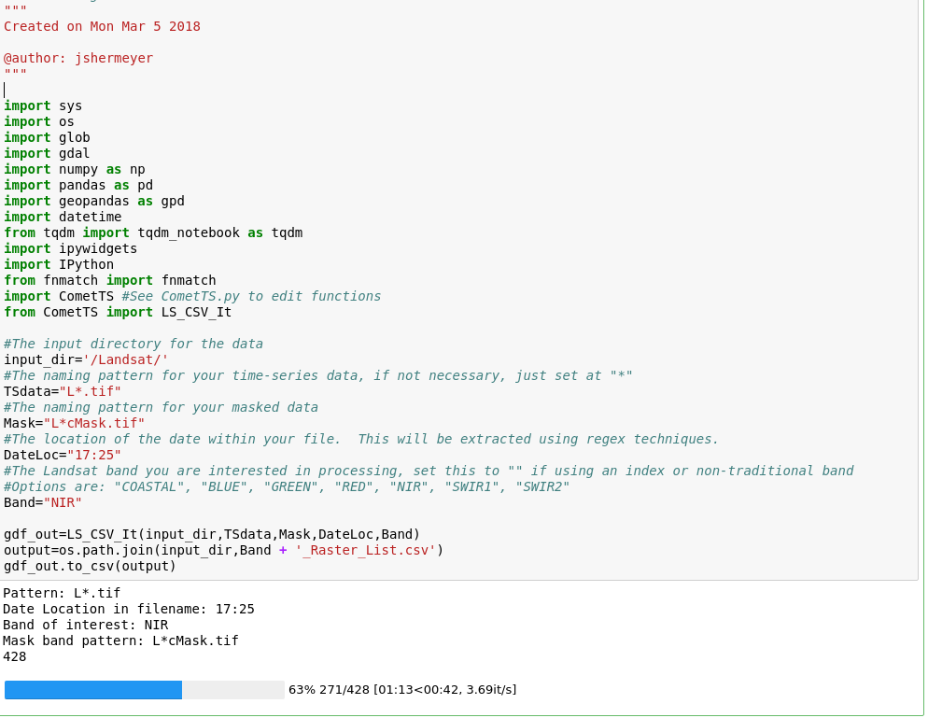

**Figure 9: The interface for the Landsat CSV Creator Script**

**Identify areas of interest:**

New Orleans is broken up into several small communities; each was affected in slightly different ways by storms such as Katrina. I started by identifying a few of these communities to see how they were affected (Figure 10). I’d recommend using a tool like geojson.io for creating shapefiles or using Google Earths historical satellite imagery to look back in time and identify areas of change. These places can be saved by drawing a polygon and then saving them as a kml. All items should be projected to the same projection as your imagery, for Landsat this is in a UTM zonal format. This information can be extracted from the MTL metadata textfile that is distributed with each image or from the image itself in a program like QGIS.

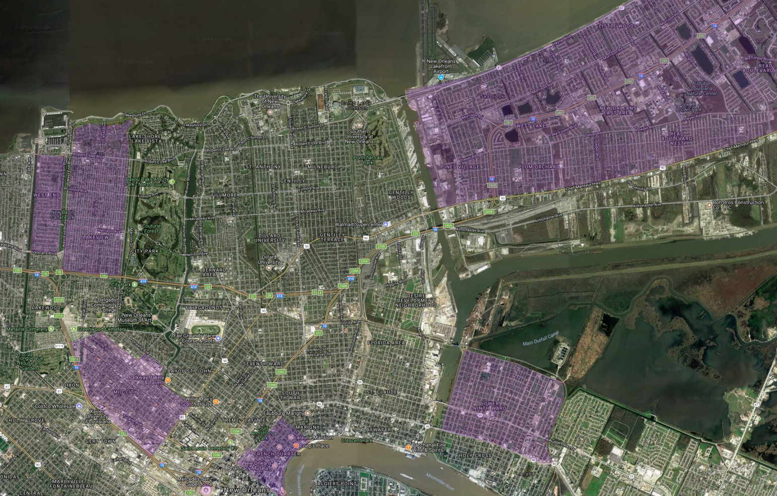

**Figure 10: Various communities of interest across New Orleans.**

**Plot and visualize changes over time:**

Open the CometTS_Visualizer notebooks, set your inputs, and execute the analysis (Figure 11). My first run took approximately 7 minutes to complete per band per AOI. I have added another expansion script that is a specialty plotter for Landsat that can be used to visualize up to 3 bands at once to easily determine relationships between each band, and visualize how they respond to change over time (Plot-Results-Landsat.ipynb).

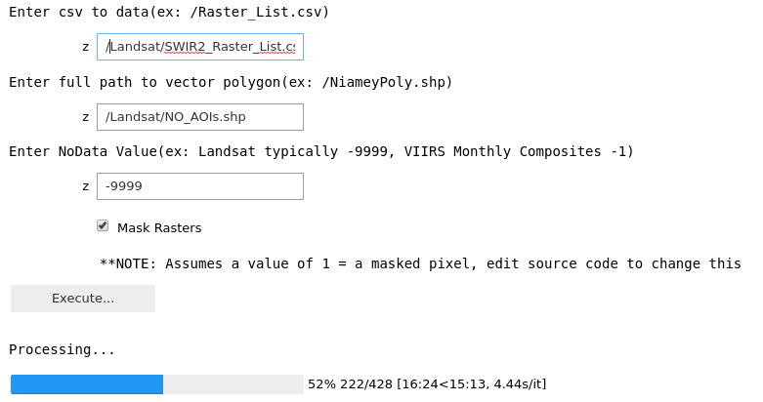

**Figure 11. Inputs for the CometTS visualizer notebook when working with Landsat data**

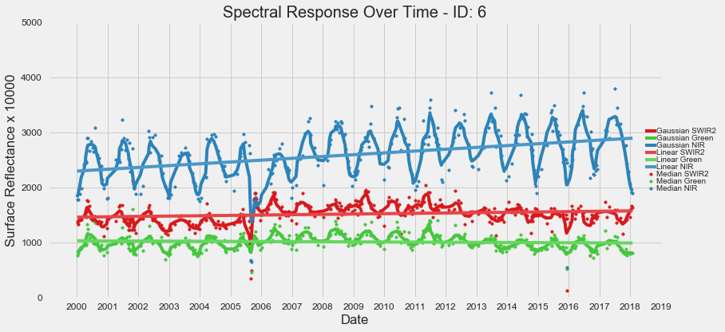

**Figure 12: Visualizing changes in the Lower Ninth Ward, New Orleans, from 2000 to 2018 using Landsat bands SWIR2 (Red), NIR (Blue), and Visible Green (Green).**

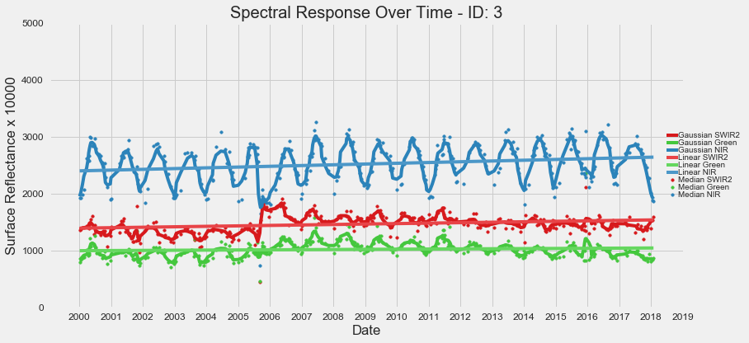

**Figure 13: Visualizing changes in Seabrook/Little Woods, New Orleans, from 2000 to 2018 using Landsat bands SWIR2 (Red), NIR (Blue), and Visible Green (Green).**

We can see the effects of Katrina in late 2005 in the communities of the Lower Ninth Ward, Seabrook, and Little Woods with the massive initial dip in reflectance across two of the three bands. Here we can see the relative value of each band for flood detection and resiliency to seasonal effects. For example the NIR band responds the most dramatically to the flood event, however it also responds the strongest to seasonal effects. Contrastingly, SWIR2 still shows a strong response to the flooding, but is less responsive to seasonality, perhaps making it a better choice for flood monitoring. Finally, visible green shows almost no response to the flood activity in this setting and has little value. Overall, this shows the necessity of multi-spectral imagery extending into the near and shortwave infrared wavelengths. Often times the visible bands are simply not sensitive enough to detect even large phenomenon such as major flooding. Additionally we can see a sharp spike following flooding, particularly in the Seabrook/Little Woods community. When investigating the imagery (Figure 14) we can see a general brown up, indicating a spread of debris, building destruction, and brown up of green vegetation.

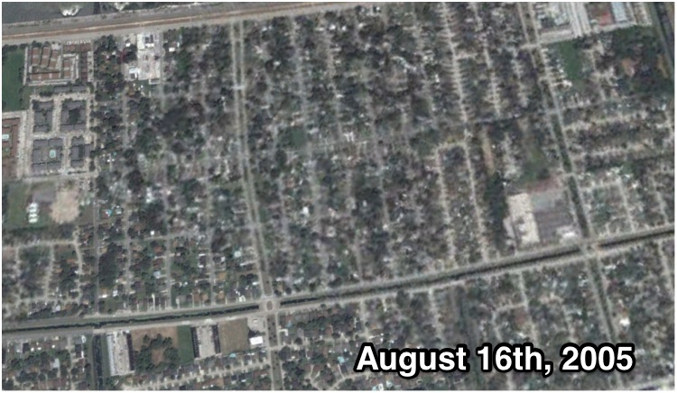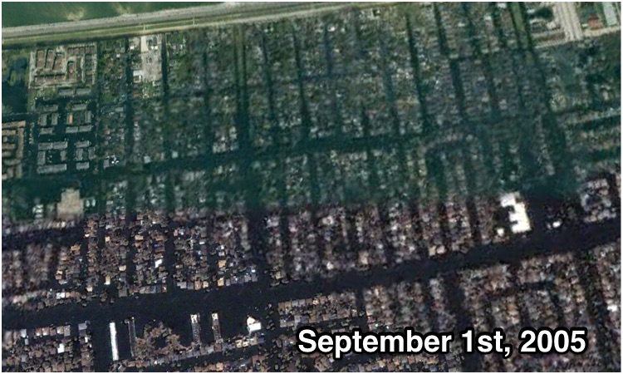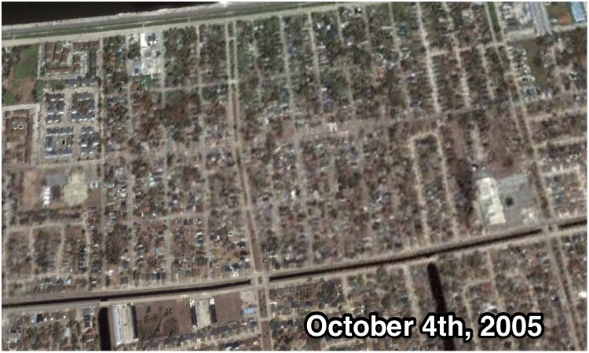

**Figure 14: A time series of high resolution DigitalGlobe Imagery showing the initial conditions in the Seabrook/Little Woods community( August 16th), followed by flooding (September 1st), and finally a spread of debris and vegetation brown up (October 4th).**

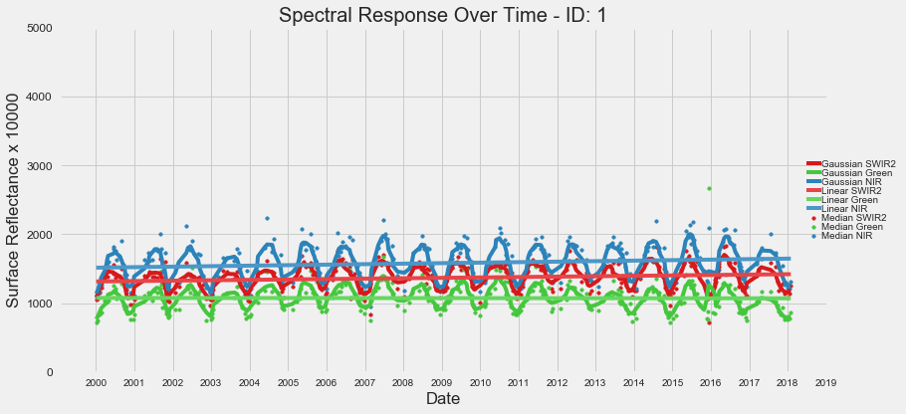

**Figure 15: Visualizing changes in the French Quarter, New Orleans, from 2000 to 2018 using Landsat bands SWIR2 (Red), NIR (Blue), and Visible Green (Green).**

Contrastingly we can see that the French Quarter (Figure 15) was not affected by the flooding and shows no significant dip in reflectance in late 2005. This shows how such spectral information can be used to differentiate flooded neighborhoods versus unaffected areas.

**Conclusions:**

This blog post showcased expansion code for CometTS and a workflow with Landsat imagery. Specifically this included a tutorial for downloading, organizing, and cloud masking Landsat, followed by the development of time series visualizations following hurricane Katrina in New Orleans. Post disaster monitoring is one application for a time series of Landsat imagery, but many others certainly exist. Ultimately, with easier accessibility to long time series of satellite imagery, CometTS could be applied for near real-time analysis of any user-defined hotspot, as a first look investigation tool, or to help assess the accuracy of land use change maps and products.

1. https://landsat.usgs.gov/
2. https://landsat.usgs.gov/what-are-band-designations-landsat-satellites